**DE - Task 2**

**Q1:** Write a query to get data having length of Rna structures more than 12 with them being added after 2008?  
  
**Query:**

SELECT *

FROM rnacen.rna

WHERE len > 12 AND timestamp > '2008-12-31'

Limit(1000);

**Result:**

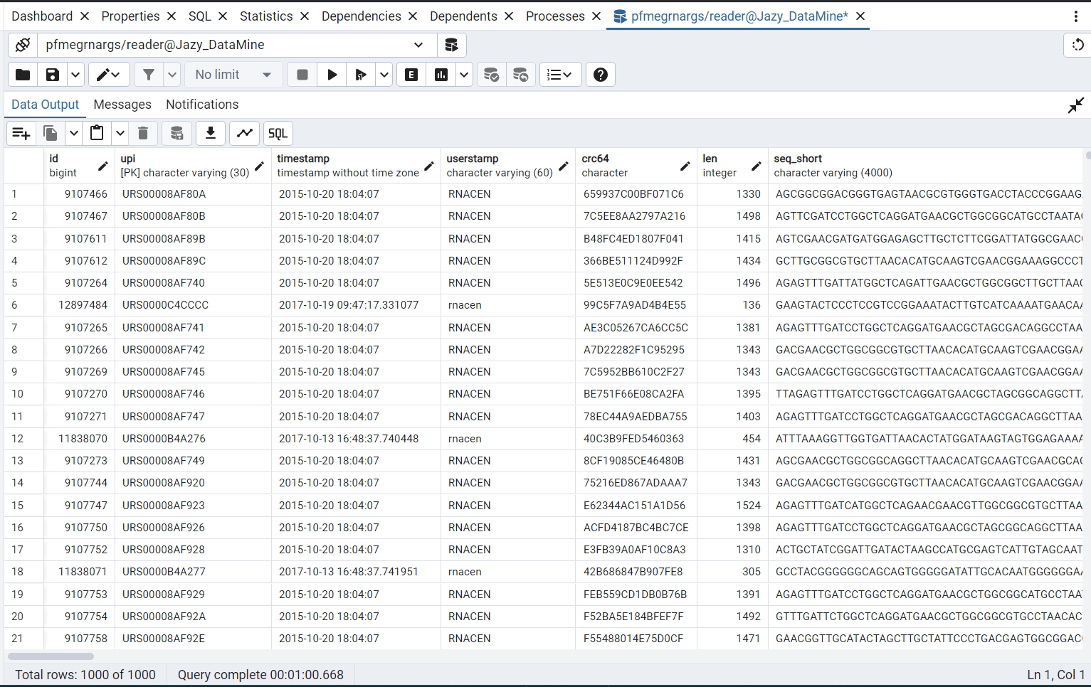

**Q2:** How many pre computed RNA are present that are still active and got their last release update before 2022?

**Query:**

SELECT COUNT(*)

FROM rnc_rna_precomputed

WHERE has_coordinates = TRUE AND is_active = TRUE AND update_date < '2022-01-01';

**Result:**

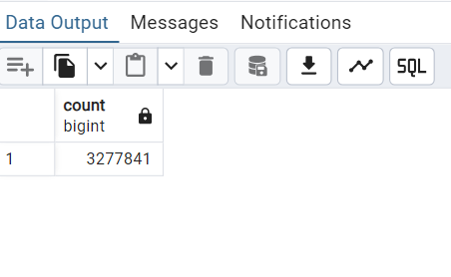

**Q3:** How many total pre computed RNA records for snoRNA and tRNA were recorded in 2011, 2016, 2014, and 2020?

**Query:**

SELECT

COUNT(*) AS total_records,

EXTRACT(YEAR FROM update_date) AS year

FROM

rnc_rna_precomputed

WHERE

(rna_type = 'snoRNA' OR rna_type = 'tRNA')

AND EXTRACT(YEAR FROM update_date) IN (2011, 2016, 2014, 2020)

GROUP BY

EXTRACT(YEAR FROM update_date)

ORDER BY

year;

**Result:**

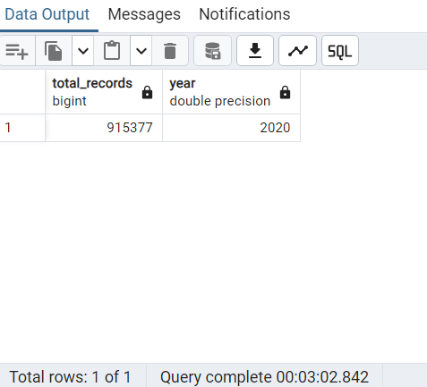

**Q4:** Can you give me the names of all databases built for RNA with minimum length other than 100, 200, 300, 400, and 15?

**Query:**

SELECT *

FROM rnc_database

WHERE min_length NOT IN (100, 200, 300, 400, 15);

**Result:**

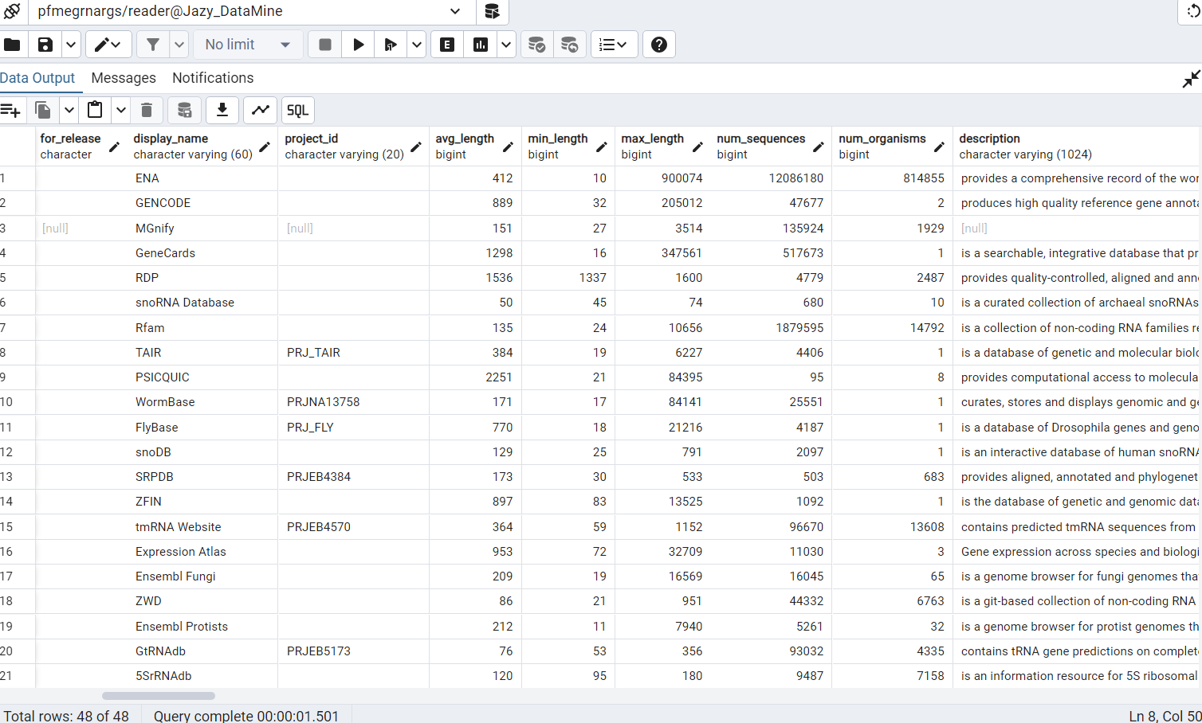

**Q5:** Can you get complete 500 records of sequences for active regions and name your column as myregions in which you are getting the region name column value. Then tell me what different chromosomes with exon_count we have for regions including center, east and north using the name you set for your column?

**Query:**

SELECT region_name As myregion

FROM rnc_sequence_regions

Where was_mapped = True

Limit 500;

**Result:**

The Screenshot of Part 1 and for last part no result can be retrieved from data because no such value named “center, north and east” existed in the given database.